**Subject: Software Construction and Development (Practical)**

**(Lab 4 - Tasks Solution)**



|  |  |
| --- | --- |
| **Roll No** | **22SW040** |
| **Section** | **One** |
| **Name** | **Farooque Sajjad** |
| **Teacher** | **Ma’am Hina** |

First Downloading all the required tools here we are usign Kali linux to do so.

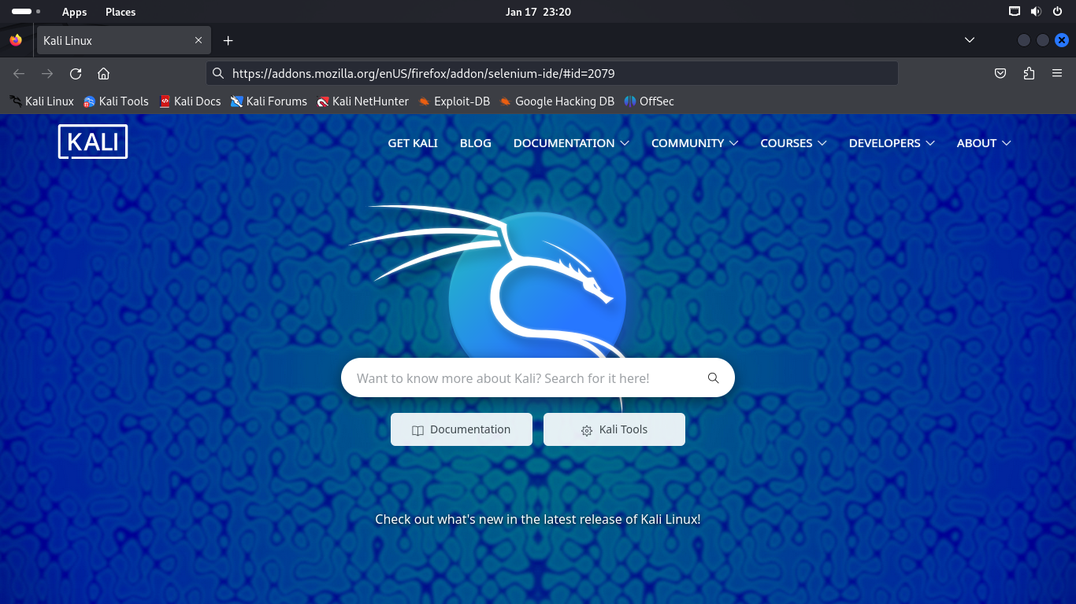

Setting up selenium tool as an extension in fire fox.

Now downloading firebug.

Downloading fire fox developer edition.

After downloading installing this tool.

Setup Selenium IDE in fire fox developer Edition tool.

Now Downloading Notepad++.

Now doing automation Testing in Selenium.

